Repeat Participant Characteristics Analysis

PY 2025

Missouri has invested significant time and effort in initiatives designed to provide high-quality services to individuals seeking employment and training assistance in Job Centers. These efforts focus on using data and information to continuously strengthen support for customers and improve service delivery.
This report compares two groups of individuals who enrolled in training through WIOA Title I programs: participants who enrolled once (the Single cohort) and participants who enrolled more than once (the Repeat cohort). The analysis reviews participant characteristics, the barriers they report, and their outcomes after leaving the program, with particular attention to employment and credential attainment. The purpose is to present clear patterns that staff and partners can use to support stronger program results.
In this report, multiple dimensions are used to compare the Single and Repeat cohorts, including training enrollment rates, age distribution, education levels, reported barriers, and program classifications. These perspectives provide a broad view of how the two groups differ in their backgrounds and service needs. The report also offers general insights to help readers better understand these patterns and the factors that may shape participant experiences.
As Missouri strives to improve services delivered through Job Centers, understanding how the customer base has changed over time is essential. Tailoring programs and supports to the needs of today’s customers can enhance service delivery and expand opportunities for individuals pursuing employment and training goals.

Methodology
This evaluation includes participants in Workforce Innovation and Opportunity Act (WIOA) Title I Adult, Dislocated Worker, and Youth Programs. All participants were also co-enrolled in the Wagner-Peyser Program. This report focuses on individuals who enrolled in at least one training program.

Data used for this analysis is from the Participant Individual Record Layout (PIRL) submitted annually to the United States Department of Labor (DOL) from Program Year (PY) 2018 through PY 2024. Participant counts reflect individuals who exited participation during each program year.
Additional data were gathered from Local Area Unemployment Statistics (LAUS). The analysis uses the unemployment rate at the time each participant exited the program and the county where the participant lived. Unemployment rates were collected by county and by month. The dataset includes Missouri and eight bordering states (Illinois, Arkansas, Iowa, Kansas, Kentucky, Nebraska, Oklahoma, and Tennessee). When a participant lived outside these states, the national unemployment rate was used.
The evaluation uses two primary indicators to assess participant outcomes:
• Employed with a year
• Credential attainment
Analysis across the seven-year period is based on annual proportions of individuals in each characteristic category. To examine the relationship between participant characteristics and outcomes, generalized linear mixed models (GLMMs) with a binomial family were employed. These models allow for estimating the likelihood of credential attainment and employment while accounting for both individual-level factors—such as gender, age, education, low-income status, employment entry, and program length—and county-level differences through random intercepts. Natural spline terms were used for age and program length to capture potential nonlinear effects. This approach supports the identification of consistent patterns across groups and provides evidence to inform service delivery improvements and enhance opportunities for customers working toward employment.
.

Performance Outcomes
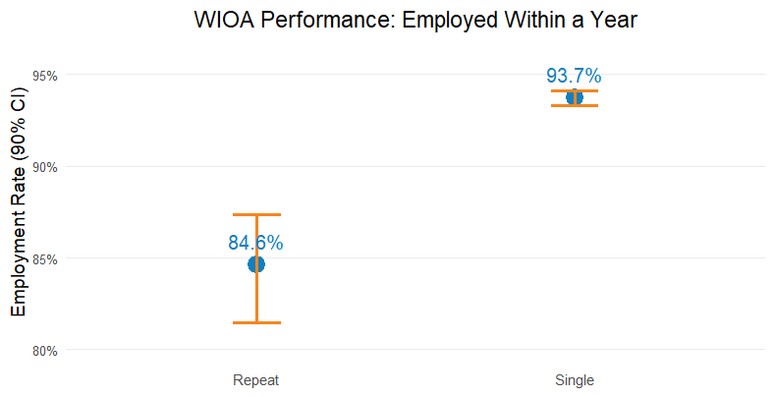
The WIOA Performance Outcomes graph compares the Single cohort to the Repeat cohort by examining differences between these groups. This comparison helps identify how repeated program engagement relates to employment outcomes, credential attainment, and overall program effectiveness. Since WIOA serves individuals with varied backgrounds and circumstances, identifying outcome patterns supports informed planning and more targeted service delivery.

Employment Outcomes
Employment outcomes differ notably between the two groups. An estimated 93.7 percent of Single participants achieved employment after program participation, with a 95% confidence interval (CI) ranging from 93.3% to 94.1%. A CI is a simple way of showing how certain we are about an estimate—it gives a range that the true number is likely to fall within. Among Repeat participants, 84.6 percent achieved employment, with a 95% CI of 81.5% to 87.4%. To ensure accuracy, estimates were generated using validated statistical models and were based on complete administrative records, reducing the likelihood of missing or inconsistent data. These results show that individuals who return to training multiple times tend to have lower employment success than those who complete training in a single enrollment cycle. This gap suggests that the Repeat cohort may face unreported/unaddressed or require enhanced support to achieve comparable outcomes.
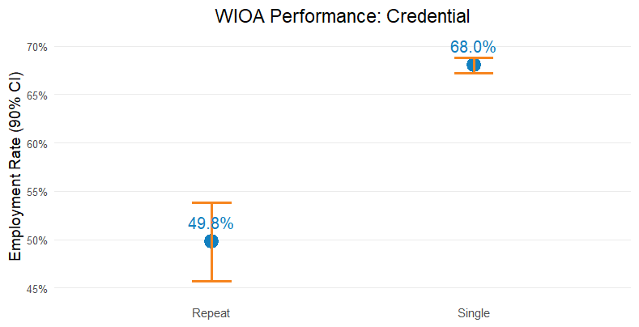

Credential Attainment
Credential attainment also varies across cohorts. Approximately 68.0 percent of Single participants earned a recognized credential (95% CI: 67.2% to 68.8%), compared with 49.8 percent of Repeat participants (95% CI: 45.7% to 53.8%). As credential attainment is a key performance measure in WIOA training programs, lower rates among Repeat participants may reflect challenges related to program persistence, academic readiness, or the suitability of selected training pathways. These patterns set the stage for deeper analysis that considers demographic and socioeconomic differences to determine whether the observed disparities reflect participant characteristics, service needs, or true performance differences between enrollment pathways.

Enrollment Over Time
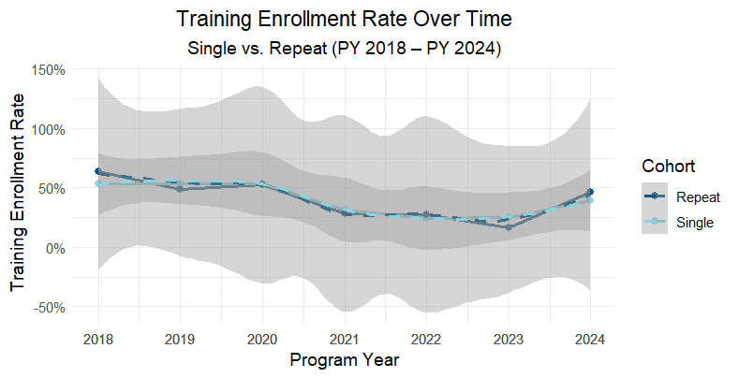
WIOA enrollment has shifted across program years, showing periods of increase and decline rather than a consistent upward pattern. These fluctuations reflect how participation in training programs can be influenced by broader labor market conditions, policy changes, and participant needs. While the enrollment levels vary from year to year, the underlying patterns highlight the importance of understanding how external factors shape engagement with WIOA services.

Training Enrollment Rates
In this report, training enrollment rates represent the share of participants who entered training out of all individuals served each program year. Reviewing these rates over time helps illustrate how the Single and Repeat cohorts participated in training and whether patterns emerged across the eight-year period. A smoothed trend line is included to make show general movement over time without being overly influenced by year-to-year fluctuations.

Trends and Patterns
The graph shows that training enrollment rates were highest for both the Single and Repeat cohorts in the pre-pandemic period, particularly around PY2018–PY2019. After this point, enrollment rates declined steadily. The decrease is especially noticeable beginning around PY2020 and continuing through PY2023 before showing early signs of stabilizing in PY2024. This pattern suggests a downward shift in the share of participants entering training, although the reasons behind this change cannot be determined from enrollment data alone.
Several factors could contribute to this decline, such as changes in participant needs or broader economic conditions. When referring to changes in overall participation levels, this analysis focused specifically on the number of individuals in the Single and Repeat cohorts, rather than WIOA participation.

Age Distribution
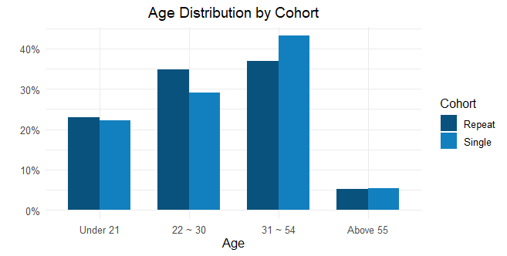
Age patterns differ between the two cohorts. On average, Repeat participants are younger than Single participants (31.54 years compared with 32.53 years). The Repeat cohort also has a larger share of individuals under age 25, representing 42.6 percent of the group versus 36.7 percent in the Single cohort.

Age Group Patterns
Across broader age bands, Single participants represent a larger share of individuals ages 30 to 54 (43.24 percent) compared with Repeat participants (36.99 percent). In contrast, Repeat participants are more concentrated in the 22 to 30 range (34.92 percent) than Single participants (29.18 percent). Shares for individuals under 21 are similar, at roughly 22 percent in both groups, and participants aged 55 or older make up a small portion of each cohort. These patterns show that the Repeat cohort skews younger, especially within early-career age ranges, while the Single cohort includes a higher proportion of mid-career adults.

Implications

The younger age profile of the Repeat cohort may reflect continued reengagement among youth and early career workers. This trend has implications for service strategies, including flexible schedules, shorter training modules, and supports tailored to individuals transitioning into the workforce. The larger mid-career share in the Single cohort suggests opportunities to strengthen services related to upskilling or career advancement.

While this analysis cannot identify the reasons behind repeat participation, the age patterns may signal different career stages represented in each cohort. The higher concentration of Repeat participants in the early 20s may reflect individuals who are still exploring or establishing a career path. Meanwhile, the larger share of Single participants ages 31 to 54 suggests that many mid-career adults engage with the program for focused upskilling or career transitions that require only one training cycle. Recognizing these distinctions can help programs tailor services to the needs of participants at different stages of career development.

Education Distribution
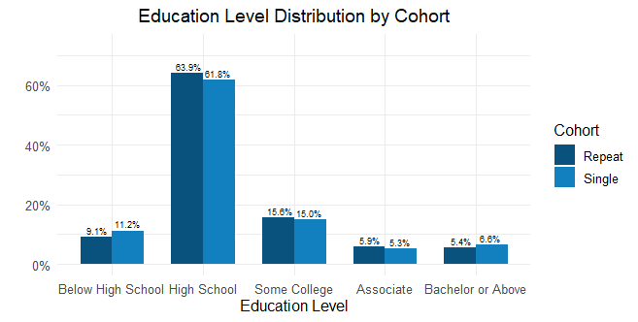
Education levels are similar across both groups, with High School completion representing the largest share. About 61.9 percent of Single participants and 63.9 percent of Repeat participants fall into this category. The remaining proportions are distributed across Some College (about 15 percent in both groups), associate degrees (about 5 to 6 percent), bachelor’s degree or higher (6.6 percent for Single and 5.4 percent for Repeat), and Below High School (11.2 percent for Single and 9.1 percent for Repeat). These patterns show that both groups share a similar overall profile, centered on High School completion, with small differences at the lower and higher ends of the education range.

Education Group Patterns
The Repeat cohort contains a slightly higher proportion of participants whose highest education level is High School, as well as modestly higher shares in the Associate degree and Some College categories. In comparison, the Single cohort includes higher proportions of individuals in the Below High School category and the bachelor’s degree or above category. Although the distribution varies across specific levels, the overall education profiles of the two groups remain broadly similar.

Implications
For the Repeat cohort, the concentration at the High School level suggests value in strengthening pathways into industry-recognized credentials or community college programs, such as short-term certificates or options that award credit for prior learning. For the Single cohort, the higher share of participants without a High School diploma points to the continued importance of basic skills instruction, GED/HiSET preparation, and wraparound supports that can improve readiness for training. The presence of Bachelor’s-level participants also indicates a need for advanced upskilling options, including specialized certifications or training linked to in-demand roles.

Barriers
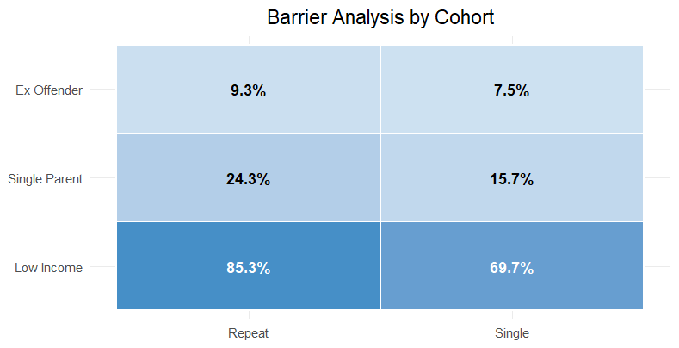

WIOA collects information on seven potential barriers when participants complete applications: Homelessness, Low Income, English Language Learner, Basic Skills Deficiency, Cultural Barriers, Single Parent status, and Ex-Offender status. This evaluation focuses on three of the barriers—Low Income, Single Parent, and Ex-Offender—because they are most consistently reported and show the clearest differences between the Single and Repeat cohorts. Rates include individuals with unknown values to provide a complete view of data quality and avoid overstating prevalence.

Barrier Patterns

Low Income is the most common barrier for both groups, especially among Repeat participants. About 85.3 percent of Repeat participants fall into this category, compared with 69.7 percent of Single participants. Single Parent is the second most common barrier, with 24.3 percent of Repeat participants and 15.7 percent of Single participants reporting this barrier. Ex-Offender status appears less often overall—9.3 percent for Repeat participants and 7.5 percent for Single participants—but is still more common within the Repeat cohort. These patterns suggest that Repeat participants face a more concentrated set of financial and family-related challenges, as well as somewhat higher reentry needs.

Implications
These patterns have several implications for service planning. The high prevalence of Low Income among Repeat participants highlights the need for strong financial-stabilization supports, including transportation assistance and short-term emergency aid. The higher share of Single Parents suggests opportunities to expand childcare solutions and offer more flexible training schedules. The elevated Ex-Offender rate points to the continued importance of targeted reentry supports for justice-involved individuals. Tracking unknown values and reviewing barrier differences by cohort can help identify gaps in data capture and support more effective service delivery.

Training programs Distribution (By CIP Code)

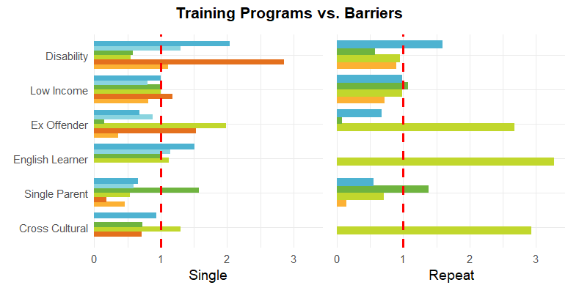
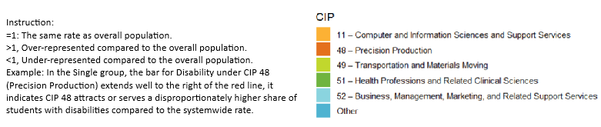

This graph examines how participant barriers vary across instructional program clusters, using Classification of Instructional Programs (CIP) codes. The analysis identifies where certain barriers occur more often than expected by comparing the rate within each CIP against the overall rate. Higher-than-expected values signal that specific barriers are more concentrated in certain fields of study. Across both Single and Repeat cohorts, several CIP groups show consistent patterns, indicating that barriers tend to cluster by program area rather than appearing at random.

Patterns Across CIP Clusters
Some program areas show much higher concentrations of barriers. CIP 48 (Precision Production) and CIP 49 (Transportation and Materials Moving) have the strongest patterns, with higher rates of Disability, Ex-Offender status, and English Learner status compared with the overall population. These results suggest that students entering these programs are more likely to face economic instability, reentry challenges, or language barriers. In contrast, programs such as CIP 11 (Computer and Information Sciences) have much lower levels of these barriers. These programs tend to draw participants with more academic preparation, greater income stability, and fewer structural challenges.
Repeat participants often show even stronger barrier patterns than Single participants within the same CIP groups. For example, in CIP 49, repeat enrollees show higher rates of reentry-related barriers and language supports than their single-enrollment peers. Similar patterns appear in CIP 51 (Health Professions) and other service-related fields, where Single Parent status and Disability are more concentrated. These trends suggest that individuals who return for additional training may be those facing the most complex personal and economic circumstances.

Implications
Differences across CIP groups point to opportunities for targeted support. Programs such as CIP 48 and CIP 49 may benefit from integrated services that include disability accommodations, reentry support, and English language resources, as well as partnerships with community organizations that specialize in workforce reentry. CIP 51 could strengthen outcomes through childcare supports, family-resource navigation, and flexible course options. Programs such as CIP 11, which show lower levels of barriers, may require fewer intensive supports but could consider outreach strategies to broaden participation among underrepresented groups. Across all CIP areas, repeat participants may benefit from enhanced advising and case management, given their higher levels of reported barriers.

Key Takeaways and Actionable Recommendations

The analysis across enrollment trends, participant characteristics, barriers, and training program patterns reveals several consistent themes that can guide program improvement.
- Repeat participants are younger on average. Participants are more concentrated in the 22–30 age range, while Single participants have more mid-career adults ages 30–54. These patterns suggest that younger individuals are more likely to return to Job Centers for additional training.
- Education profiles are similar across cohorts, with High School completion being the most common level. The Repeat cohort shows slightly higher shares in High School and Some College categories, while the Single cohort includes more individuals both below and above that range. These differences are modest but help refine service strategies.
- Low Income is the most common barrier in both groups and is especially high among Repeat participants. Single Parent and Ex-Offender statuses also appear more often among Repeat participants, indicating more complex economic, family, and reentry needs. Based on these findings, several actions can help strengthen program delivery and participant outcomes
- Strengthen Support for Repeat Participants: Expand targeted case management, transportation and financial assistance, and reentry supports to address the higher concentration of barriers and improve overall outcomes
- Adjust Training Capacity Based on Enrollment Shifts: Monitor participation changes and adapt scheduling, staffing, and outreach to ensure training opportunities match evolving demand across program years.
- Tailor Services to Younger Repeat Participants: Increase flexible scheduling options, short-term training modules, and career-transition supports to meet the needs of younger individuals returning for additional training.
- Strengthen Foundational Skills and Upskilling Pathways: Expand bridge programming, literacy and basic-skills supports, and postsecondary transition pathways. Maintain advanced upskilling options for participants with higher levels of education.
Understanding how participant needs change over time is essential for delivering effective services in Missouri’s Job Centers. The data and information may be applied to strengthen support strategies and improve employment and training outcomes. The insights gained from this analysis will help guide continuous improvement and ensure services remain responsive to the needs of individuals pursuing employment and training goals.

